**Week 4 -HandsOn**

**Hello World RESTful Web Service**   
  
Write a REST service in the spring learn application created earlier, that returns the text "Hello World!!" using Spring Web Framework. Refer details below:  
  
**Method:** GET  
**URL:** /hello  
**Controller:** com.cognizant.spring-learn.controller.HelloController  
**Method Signature:** public String sayHello()  
**Method Implementation:** return hard coded string "Hello World!!"  
**Sample Request**: http://localhost:8083/hello  
**Sample Response:** Hello World!!   
  
**IMPORTANT NOTE**: Don't forget to include start and end log in the sayHello() method.  
  
Try the URL http://localhost:8083/hello in both chrome browser and postman.  
  
SME to explain the following aspects:

* In network tab of developer tools show the HTTP header details received
* In postman click on "Headers" tab to view the HTTP header details received

**Code and output :**

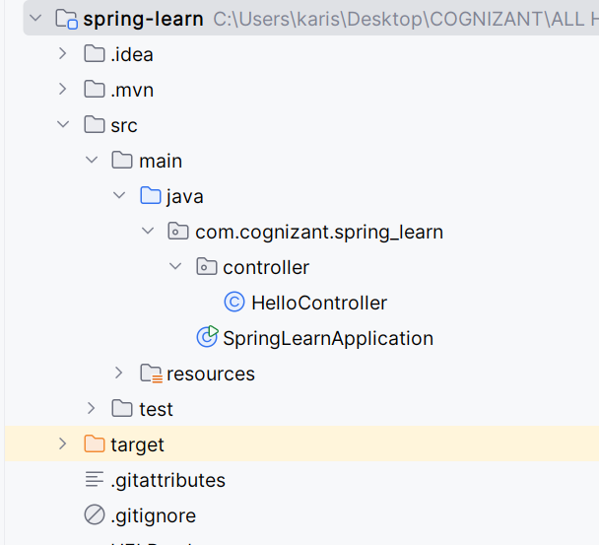

**Application.properties:**

spring.application.name=spring-learn  
logging.level.org.springframework=info  
logging.level.com.cognizant.spring_learn=debug  
logging.pattern.console=%d{yyMMdd}|%d{HH:mm:ss.SSS}|%-20.20thread|%5p|%-25.25logger{25}|%25M|%m%n  
server.port=8083

**HelloController.java :**

package com.cognizant.spring_learn.controller;  
  
import org.slf4j.Logger;  
import org.slf4j.LoggerFactory;  
import org.springframework.web.bind.annotation.GetMapping;  
import org.springframework.web.bind.annotation.RestController;  
  
@RestController  
public class HelloController {  
  
 private static final Logger *LOGGER* = LoggerFactory.*getLogger*(HelloController.class);  
  
 @GetMapping("/hello")  
 public String sayHello() {  
 *LOGGER*.info("START");  
 String response = "Hello World!!";  
 *LOGGER*.info("END");  
 return response;  
 }  
}

